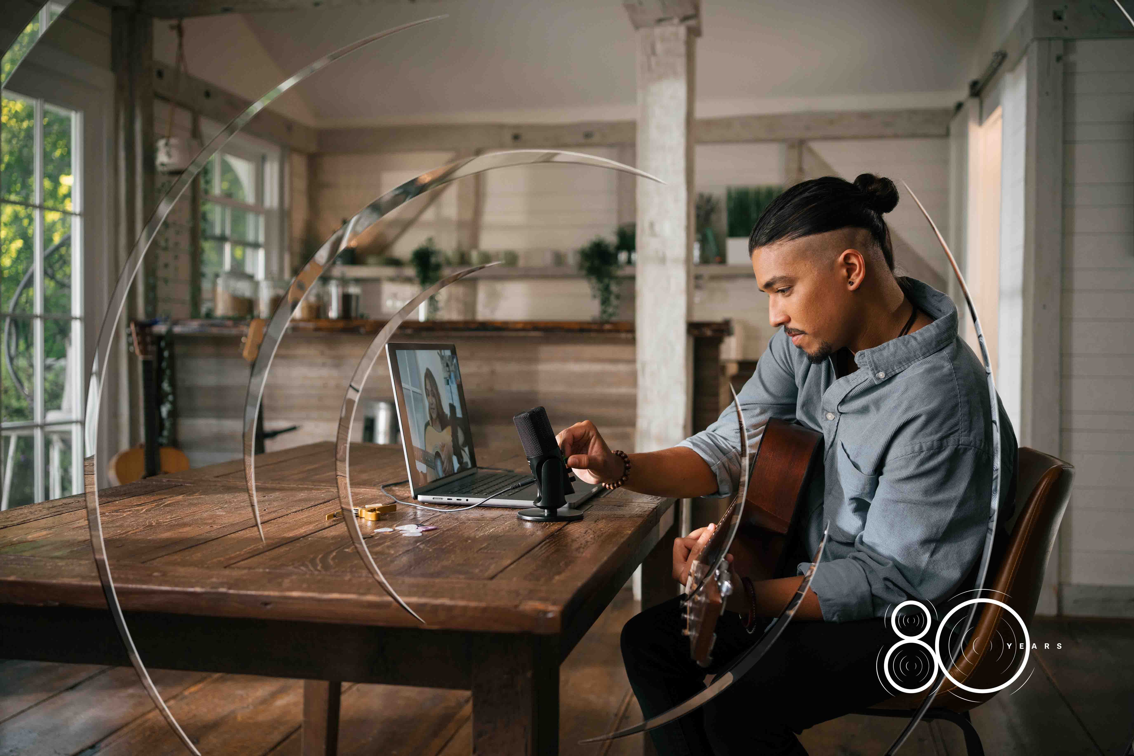

Limited-time 80th anniversary deals from Sennheiser

Wedemark, 18 June 2025 — Audio specialist Sennheiser has turned 80 this month, and kicks off a series of anniversary promotions to celebrate the occasion at participating dealers and the company’s webshops, where available. “We would like to celebrate this special occasion together with users and fans of the brand,” says Jimmy R. Landry, Category Market Manager MI at Sennheiser. “The products for the 80th anniversary specials have been selected based on their popularity, elevating your craft.” Starting with the IE 100 PRO in-ear monitor in July and finishing with the HD 280 PRO in December, there will be discounted products every month that make the hearts of musicians and creators beat faster.

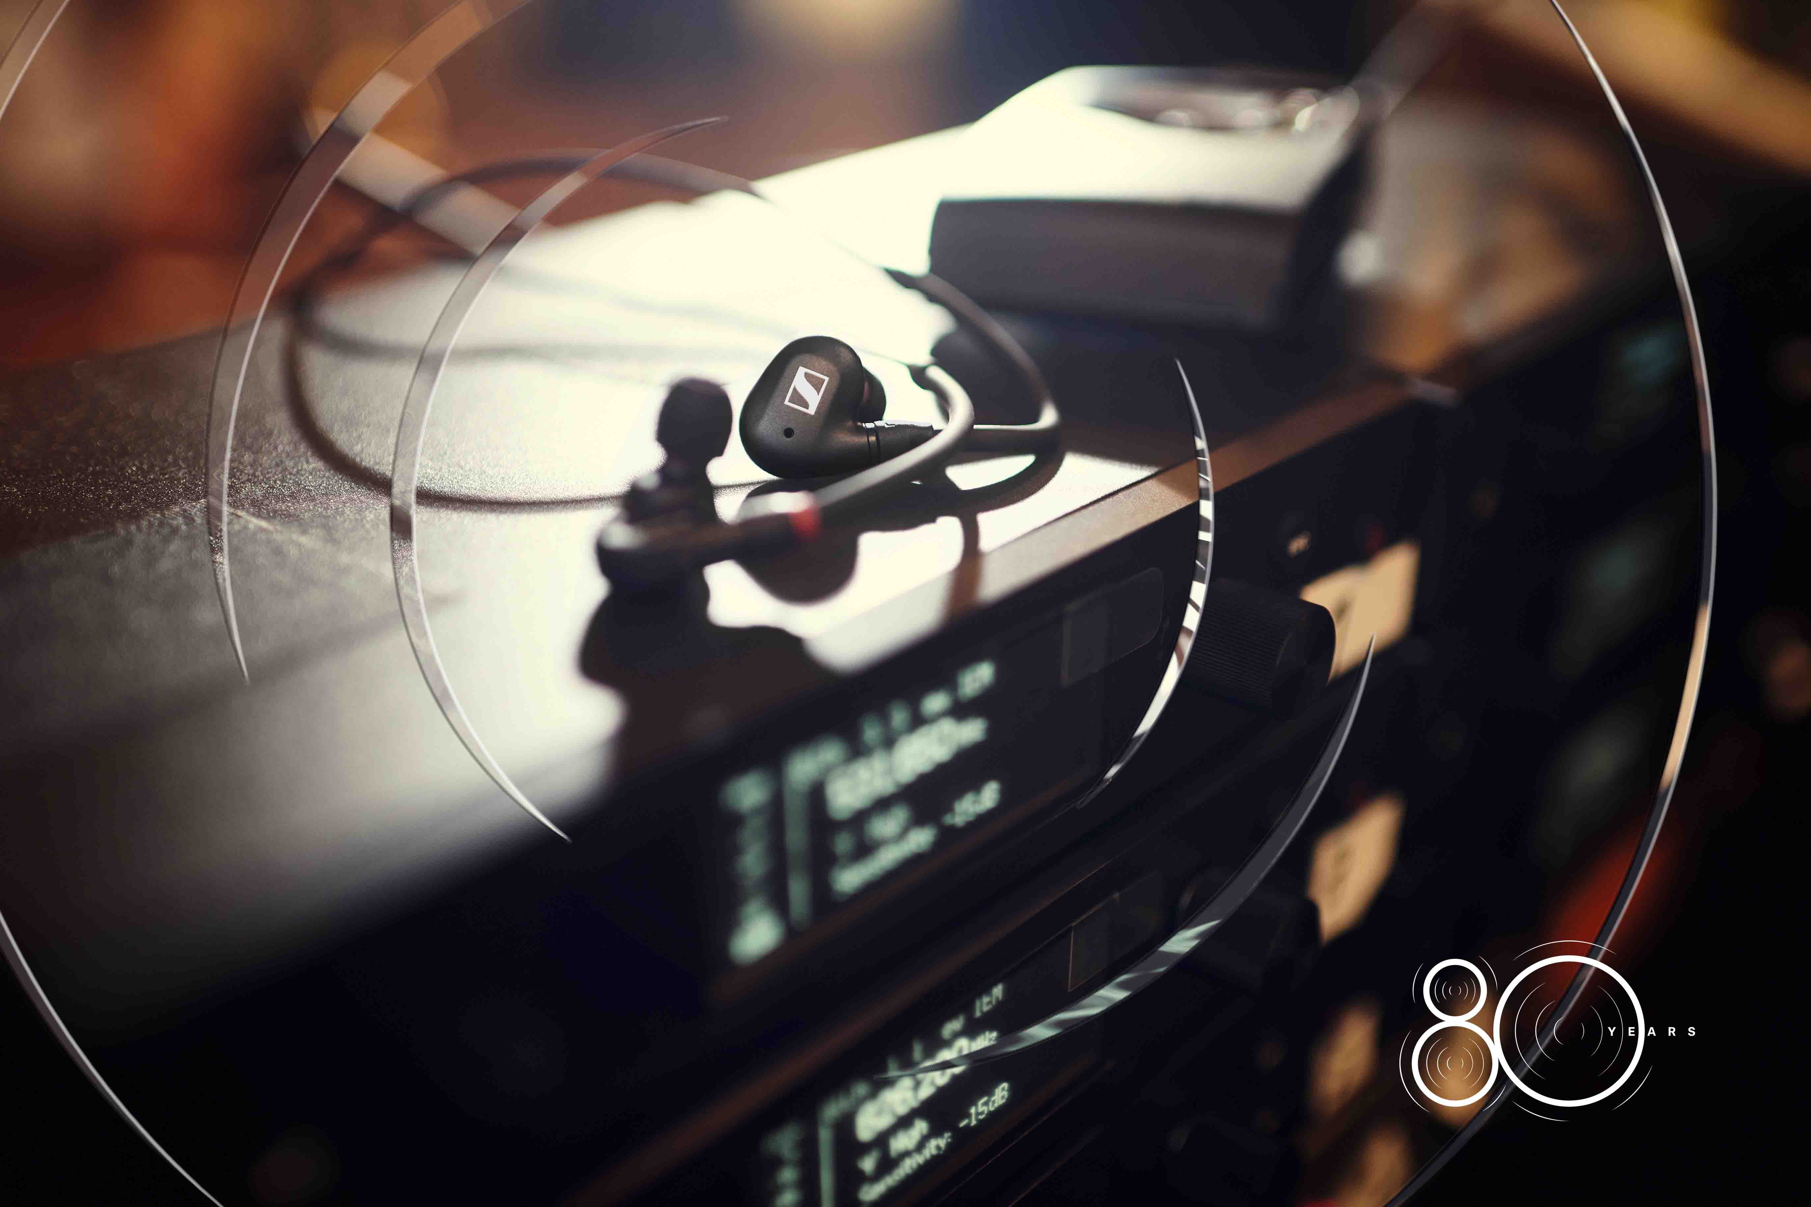 | The IE 100 PRO is on anniversary promotion in the month of July

July: The IE 100 PRO in-ear monitor
Whether red, black or clear, the IE 100 PRO in-ear monitors have won the hearts of many professional IEM users. Providing a defined, detailed and powerful monitoring sound, they cover the entire audio bandwidth with a single dynamic driver, ensuring the consistency and precision that is so essential on the live music stage. Also on promotion is the IE 100 PRO Wireless, which adds a Bluetooth module to enable use of the IE 100 PRO with mobile devices.

August: The HD 25 LIGHT
The HD 25 LIGHT has the same great transducers as used in the legendary HD 25, but with a simpler headband design to make the classic HD 25 sound available for everyone.

September: The e 609 Silver
The evolution e 609 Silver is a rugged workhorse that has been designed to simply be hung in front of a guitar cab to mike it face-on. Its super-cardioid pick-up pattern provides isolation from other onstage signals, and the mic features an advanced shock-mount design and a hum compensating coil.

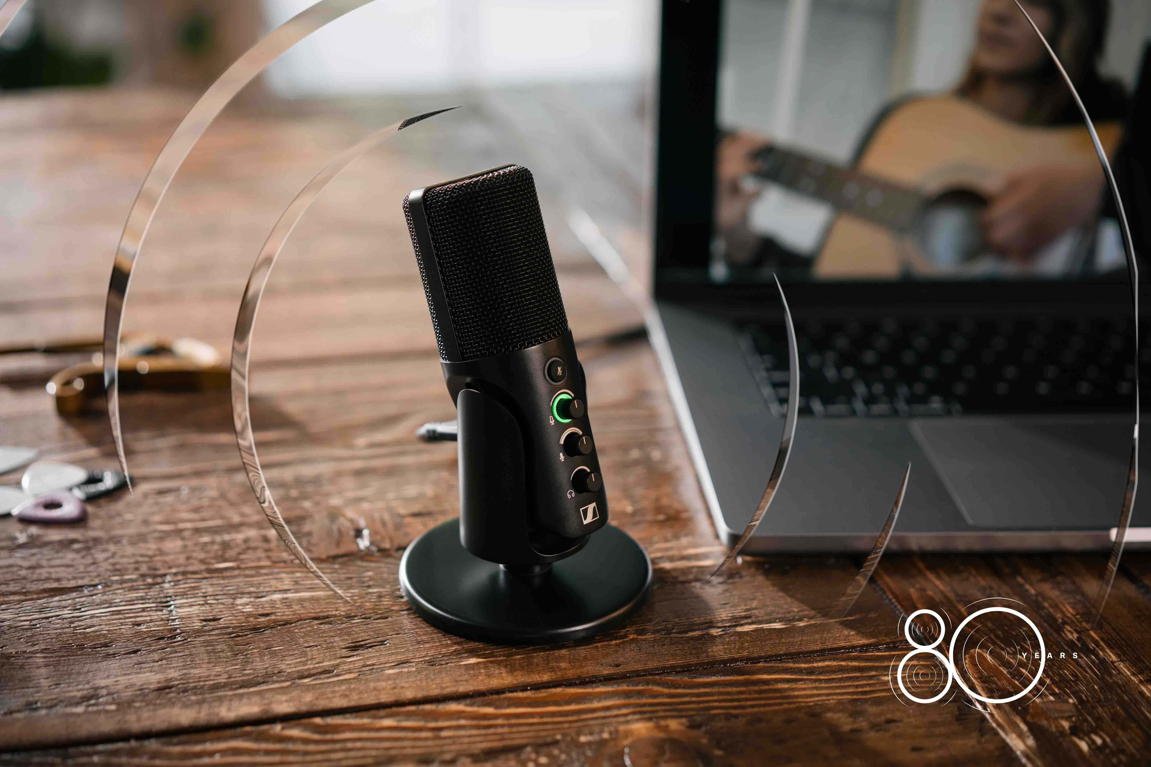 | Streaming and podcasting made easy – the Profile USB microphone is on promotion in October

October: The Profile USB Microphone
Created for streaming and podcasting, the Profile USB Microphone works right out of the box: No app or software required, with all controls directly accessible on the sleek USB-C microphone. Also on promotional offer is the Profile USB Streaming Set, which includes a boom arm with intelligent cable management.

November: The e 835 and the e 845
Two stage stars: the cardioid evolution e 835 and its super-cardioid counterpart, the e 845, are microphones that lend projection, quality and clarity to vocals. Also on promotion are the e 835-S and e 845-S product versions with noiseless on/off switch, as well as the e 835 three-pack and e 835-S three-pack.

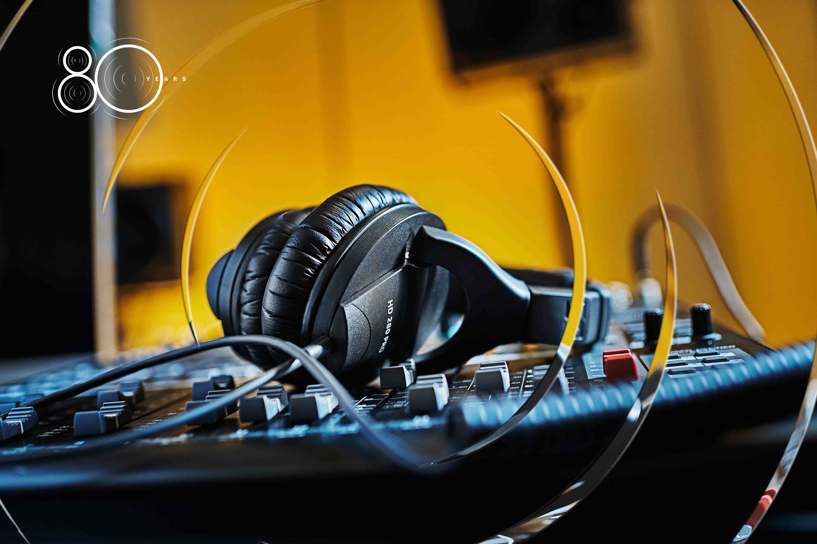 | A classic – the closed, circumaural HD 280 PRO monitoring headphones are on promotion in the month of December

December: The HD 280 PRO
The closed, circumaural HD 280 PRO monitoring headphones are a monitoring legend in their own right. They feature accurate, linear audio reproduction, high attenuation of ambient noise and a rugged, collapsible design with swiveling earpads.

(Ends)

The high-resolution images accompanying this media release and neutral product images can be downloaded here.

About the Sennheiser Brand – 80 Years of Building the Future of Audio
We live and breathe audio. We are driven by the passion to create audio solutions that make a difference. This passion has taken us from the world’s greatest stages to the quietest listening rooms – and made Sennheiser the name behind audio that doesn’t just sound good: It feels true. In 2025, the Sennheiser brand celebrates its 80th anniversary. Since 1945, we stand for building the future of audio and bringing remarkable sound experiences to our customers. While professional audio solutions such as microphones, meeting solutions, streaming technologies and monitoring systems are part of the business of Sennheiser electronic SE & Co. KG, the business with consumer devices such as headphones, soundbars and speech-enhanced hearables is operated by Sonova Holding AG under the license of Sennheiser.

www.sennheiser.com
www.sennheiser-hearing.com

Global Pro Audio Press Contact
Stephanie Schmidt
stephanie.schmidt@sennheiser.com
+49 (5130) 600 – 1275

